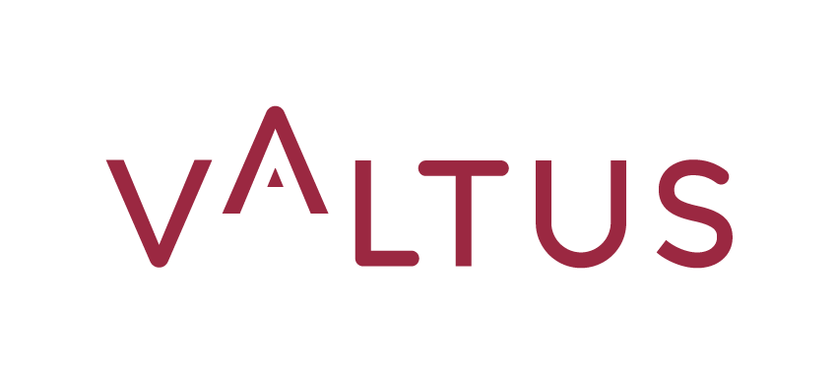

PRESS RELEASE
PARIS, March 5th, 2024

‘VALTUS’ & ‘DR. MAIER + PARTNER’ LAUNCH VALTUS IN GERMANY TOGETHER TO OFFER EXECUTIVE INTERIM MANAGEMENT SERVICES IN THE GERMAN MARKET

‘Dr. Maier + Partner’ has been a leader in Executive Search and HR consulting in Germany for over 50 years. Valtus, with capabilities to help clients all over the world, is a global leader in Executive Interim Management.

Together the two companies are launching Valtus in Germany to offer top-notch services in the German market.

The Executive Interim Management industry is growing 10-15% every year supported by strong underlying trends. The global market is worth more than 8 billion euros. Germany is a market valued at over 2.75 billion euros¹. This strategic move marks a significant step in deepening Valtus’ presence in a key economy at the heart of Europe.
Philippe Soullier, now Chairman of ‘Valtus Group’, says: "This joint venture is a major asset for Valtus’ successful second establishment in the DACH region (after acquisition in Austria in 2022). We believe this partnership with a trusted player in a growing market is an effective way to accelerate the overall expansion of Valtus Group."

Heinrich Schaible, Managing Partner at ‘Dr. Maier + Partner’ says: “We are pleased to be partnering with Valtus and are convinced we have much to learn from each other. Our aim is to offer high value Executive Interim Management services together, emphasizing excellence while sharing our in-depth knowledge of local markets.”

Aymeric Bas, Managing Partner International at Valtus says: “I am very enthusiastic about our partnership with ‘Dr. Maier + Partner’ in Germany. This joint venture is an important cornerstone in our international growth agenda and is instrumental for our Cross Border Initiative plan.”

¹ DDIM (German Interim Management Association)

About VALTUS
Valtus helps clients all over the world overcome their most difficult challenges. For over 20 years, the company has committed itself to drive the development of the Executive Interim Management industry. With capabilities all over the world, Valtus today runs more than 900 assignments in all continents ever year.

With successive international acquisitions since 2018 and the launch of Valtus Alliance in 2023, our international network, we are qualified to handle complex situations and implement customized, immediately operational management solutions in 14 countries: Austria, Belgium, the Netherlands, Brazil, Denmark, France, the United Kingdom, Finland, Germany, Italy, Sweden Norway, Singapore and Spain.

With a culture based on the values Care, Dare and Share the company is committed to unleash human magic to create lasting business results. Valtus is certified by Bureau Veritas since 2010 and achieved its Ecovadis Platinum certification in 2023. www.valtus.fr / @ValtusT

Contact
Clément NAIZET – cn@iconic.fr

